**Lessons Page**

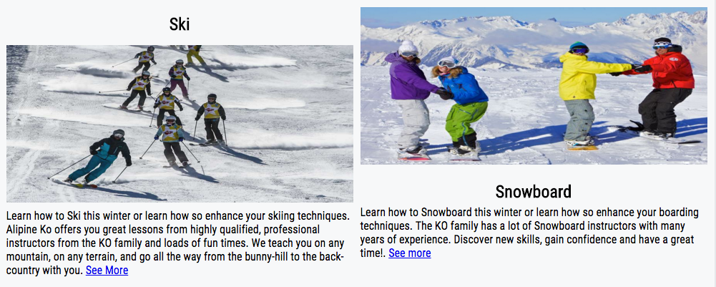

Switched up the layout of the headers and pictures trying to see if the contrast would make it pop better

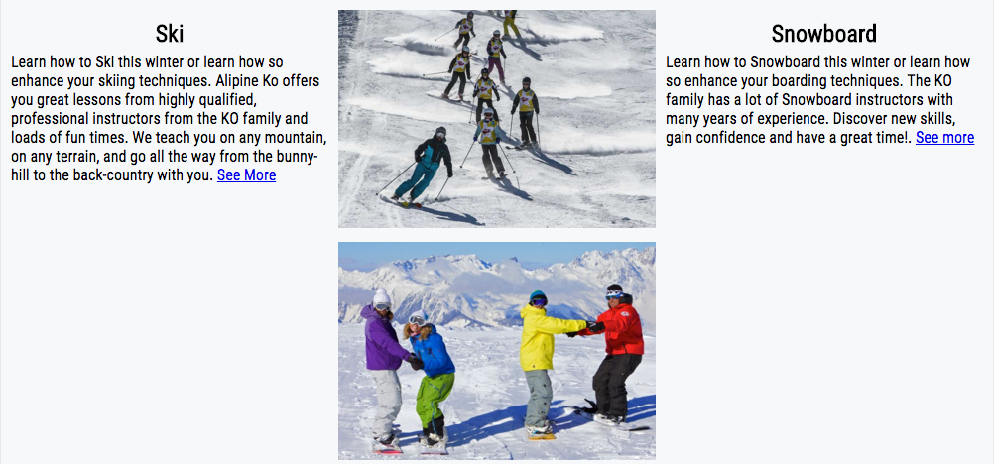

Tried the header before the image to see if the content would look better closer to the image.

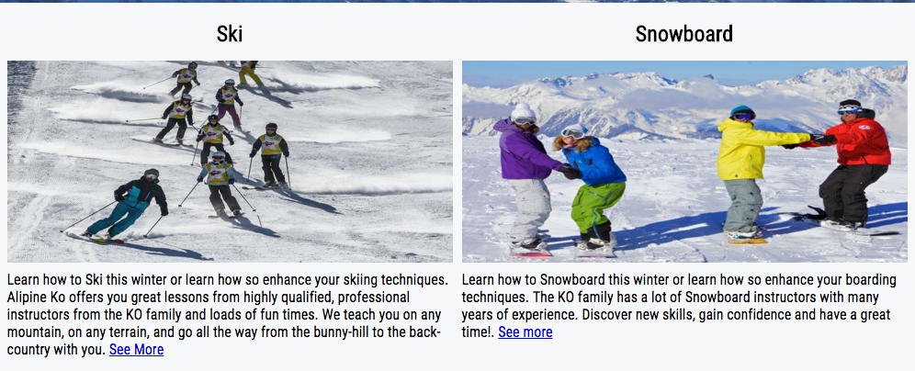

Moved the headers on top of the images. Trying to see if the headers would be more visual.

**Skiing Lessons Page**

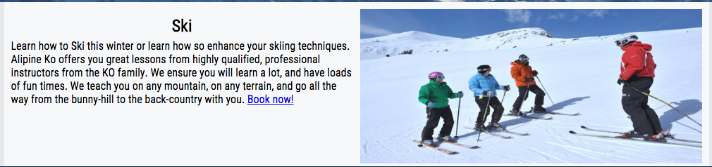

Made the picture its own div so the the picture could be on the right side. Trying to see if the picture would fit better this way.

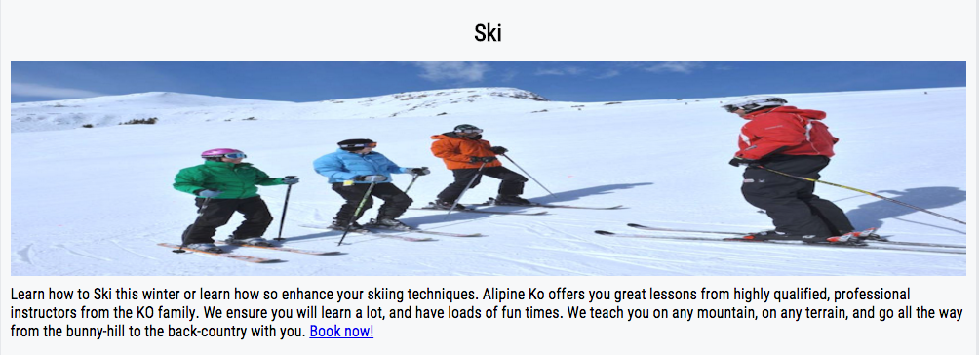

Moved the header above the image.

**Snowboard Lessons Page**

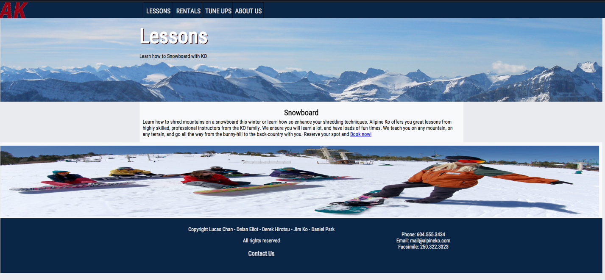

Move the image to the bottom to make it seem like a second banner.

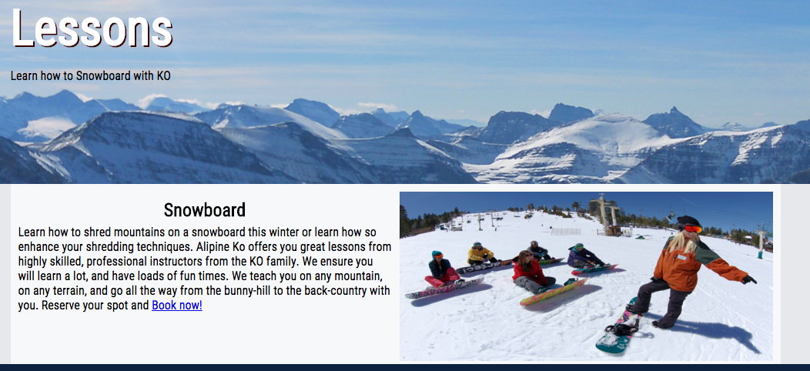

Made a div for the picture so it sits next to the text. 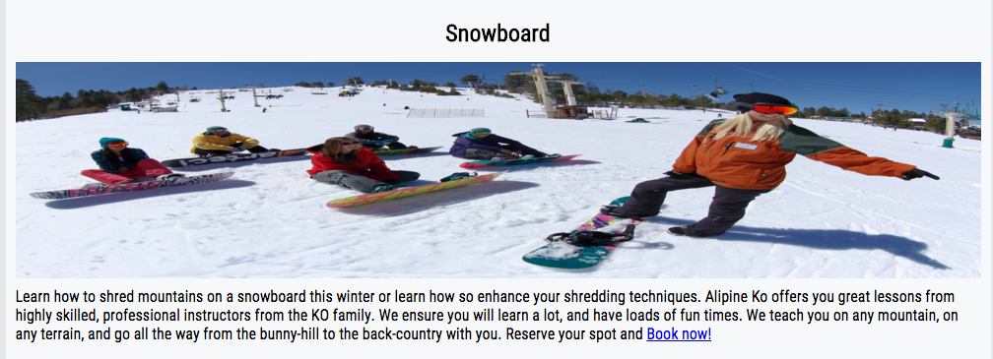

Made a div for the pictures and placed them between the content.